Peace Lutheran Church Midweek Lent 2 March 9, 2022

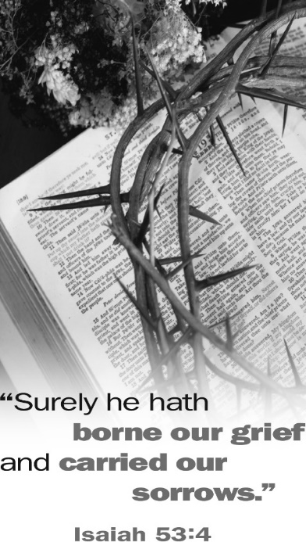
Sermons Preached by Jesus’ Enemies

Sometimes God used the most unlikely of people as His spokesmen. They were people of whom we, as Christians, would never approve. At times He even proclaimed eternally saving truths through His enemies. Some didn’t understand what they said. Others understood what they said but didn’t believe it. Some meant one thing while God used their words to say something else that would be to our blessing. These divine truths from which Christians derive great comfort and hope are the subject of our Lenten meditations this year. Through the things they said may God help us gain insights into our lives in Him and the wonders of salvation that He worked in our behalf.

Sermons Preached by Jesus’ Enemies

# 1: Caiaphas: “It Is Better That One Man Die for the People”
Lenten Supper: Soup – Elizabeth Lehmann, coordinator
# 2: Pilate’s Wife: “Have Nothing to Do with that Righteous Man”
Tonight’s Lenten Supper: Italian – Kathy Lane, coordinator
# 3: Sanhedrin: “We Have Heard It from His Own Lips”
Lenten Supper: Mexican – Holly Hampton, coordinator
# 4: Judas: “I Have Sinned, for I Have Betrayed Innocent Blood”
Lenten Supper: Breakfast – Jackie Inniger, coordinator
# 5: Pilate’s Soldiers: “Hail, King of the Jews!”
Lenten Supper: Potluck – Barbara Grant, coordinator
# 6: Chief Priests: “He Saved Others, but He Can’t Save Himself”
Lenten Supper: Hamburgers/Dogs – Ryleigh Bouldin, coordinator

The Order of Worship

(No offering will be taken in the service this evening. The offering plates will be
on the table in the narthex where you may leave your offering after the service.)

Opening Hymn: “Come to Calvary’s Holy Mountain” 149

The Sermon: Sermons Preached by Jesus’ Enemies
Pontius Pilate’s Wife: “Have Nothing to Do with that Righteous Man”
Matthew 27:19

The Hymn: “Jesus! And Shall It Ever Be” 346

The Order of Vespers: Hymnal page 41 (The “Hallelujah” is not sung during Lent)

The Psalm: Psalm 38 Hymnal page 132

The Passion History of our Lord - Part 2: In the Garden of Gethsemane

The Close of Vespers: Hymnal pages 42-45
- The Versicle
- The Nunc Dimittis (bottom of p.43)
- The Prayers
- The Benediction

The Closing Hymn: “All Praise to Thee, My God, This Night” 558

Silent Prayer

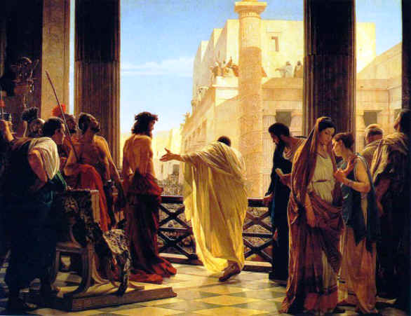
Zion Lutheran Church Midweek Lent 2 March 10, 2022

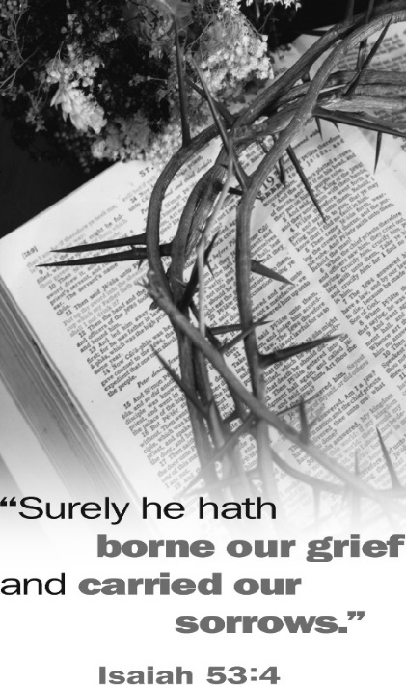
Sermons Preached by Jesus’ Enemies

Sometimes God used the most unlikely of people as His spokesmen. They were people of whom we, as Christians, would never approve. At times He even proclaimed eternally saving truths through His enemies. Some didn’t understand what they said. Others understood what they said but didn’t believe it. Some meant one thing while God used their words to say something else that would be to our blessing. These divine truths from which Christians derive great comfort and hope are the subject of our Lenten meditations this year. Through the things they said may God help us gain insights into our lives in Him and the wonders of salvation that He worked in our behalf.

Sermons Preached by Jesus’ Enemies

# 1: Caiaphas: “It Is Better That One Man Die for the People”
# 2: Pilate’s Wife: “Have Nothing to Do with that Righteous Man”
# 3: Sanhedrin: “We Have Heard It from His Own Lips”
# 4: Judas: “I Have Sinned, for I Have Betrayed Innocent Blood”
# 5: Pilate’s Soldiers: “Hail, King of the Jews!”
# 6: Chief Priests: “He Saved Others, but He Can’t Save Himself”

Lenten Potluck Suppers will held each evening before the worship service at 6 pm.

The Order of Worship

(No offering will be taken in the service this evening. The offering plates will be
on the table in the narthex where you may leave your offering after the service.)

Opening Hymn: “Come to Calvary’s Holy Mountain” 394

The Sermon: Sermons Preached by Jesus’ Enemies
Pontius Pilate’s Wife: “Have Nothing to Do with that Righteous Man”
Matthew 27:19

The Hymn: “Jesus! And Shall It Ever Be insert 347

The Order of Vespers: Hymnal page 244

The Psalm: Psalm 51

The Passion History of our Lord - Part 2: In the Garden of Gethsemane

The Orders of Vespers: Hymnal page 244
- The Song of Mary – The Magnificat
- The Prayers – page 245
- The Benediction

The Closing Hymn: “All Praise to Thee, My God, This Night” 789

Silent Prayer

