Peace Lutheran Church Ash Wednesday March 2, 2022

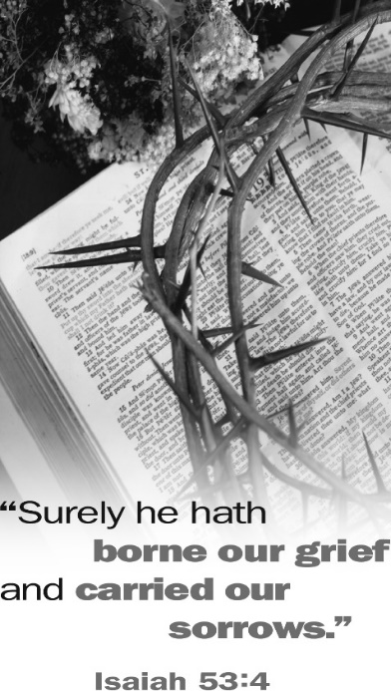
Sermons Preached by Jesus’ Enemies

Sometimes God used the most unlikely of people as His spokesmen. They were people of whom we, as Christians, would never approve. At times He even proclaimed eternally saving truths through His enemies. Some didn’t understand what they said. Others understood what they said but didn’t believe it. Some meant one thing while God used their words to say something else that would be to our blessing. These divine truths from which Christians derive great comfort and hope are the subject of our Lenten meditations this year. Through the things they said may God help us gain insights into our lives in Him and the wonders of salvation that He worked in our behalf.

Sermons Preached by Jesus’ Enemies

# 1: Caiaphas: “It Is Better That One Man Die for the People”
Tonight’s Lenten Supper: Soup – Elizabeth Lehmann, coordinator
# 2: Pilate’s Wife: “Don’t Have Anything to Do with that Innocent Man”
Next Week’s Lenten Supper: Italian – Kathy Lane, coordinator
# 3: Sanhedrin: “We Have Heard It from His Own Lips”
Lenten Supper: Mexican – Holly Hampton, coordinator
# 4: Judas: “I Have Sinned, for I Have Betrayed Innocent Blood”
Lenten Supper: Breakfast – Jackie Inniger, coordinator
# 5: Pilate’s Soldiers: “Hail, King of the Jews!”
Lenten Supper: Potluck – Barbara Grant, coordinator
# 6: Chief Priests: “He Saved Others, but He Can’t Save Himself”
Lenten Supper: Hamburgers/Dogs – Ryleigh Bouldin, coordinator

Sunday, March 6 – LWMS Mite Box Offering
Wednesday, March 9 – Women of Peace Planning Meeting at 5:30 – before the Lenten Supper
The Order of Worship

(No offering will be taken in the service this evening. The offering plates will be
on the table in the narthex where you may leave your offering after the service.)

Opening Hymn: “Jesus, I Will Ponder Now” st.1-4 140

The Sermon: Sermons Preached by Jesus’ Enemies
The High Priest Caiaphas: “It Is Better That One Man Die for the People”
John 11:49-53

The Hymn: “Alas! And Did My Savior Bleed” 154

The Order of Confessional Service: Hymnal page 46

The Psalm: Psalm 130 Hymnal page 153

The Passion History of our Lord - Part 1: The Upper Room

The Exhortation to Confession & Absolution: Hymnal pages 47-48

The Lord’s Prayer

The Institution and Distribution of the Lord’s Supper

The Closing Prayers and the Benediction: Hymnal page 49

The Closing Hymn: “Abide with Me” st.1,6,7,8 552

Silent Prayer

