Peace Lutheran Church Midweek Lent 6 April 6, 2022

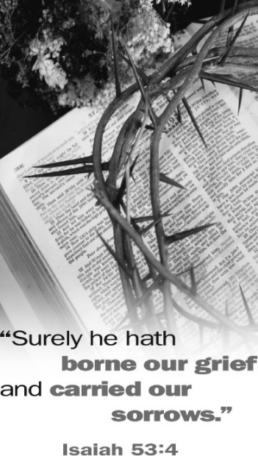
Sermons Preached by Jesus’ Enemies

Sometimes God used the most unlikely of people as His spokesmen. They were people of whom we, as Christians, would never approve. At times He even proclaimed eternally saving truths through His enemies. Some didn’t understand what they said. Others understood what they said but didn’t believe it. Some meant one thing while God used their words to say something else that would be to our blessing. These divine truths from which Christians derive great comfort and hope are the subject of our Lenten meditations this year. Through the things they said may God help us gain insights into our lives in Him and the wonders of salvation that He worked in our behalf.

Sermons Preached by Jesus’ Enemies

# 1: Caiaphas: “It Is Better That One Man Die for the People”
Lenten Supper: Soup – Elizabeth Lehmann, coordinator
# 2: Pilate’s Wife: “Have Nothing to Do with that Righteous Man”
Lenten Supper: Italian – Kathy Lane, coordinator
# 3: Sanhedrin: “We Have Heard It from His Own Lips”
Lenten Supper: Mexican – Holly Hampton, coordinator
# 4: Judas: “I Have Sinned by Betraying Innocent Blood”
Lenten Supper: Breakfast – Jackie Inniger, coordinator
# 5: Pilate’s Soldiers: “Hail, King of the Jews!”
Lenten Supper: Potluck – Barbara Grant, coordinator
# 6: Chief Priests: “He Saved Others, but He Can’t Save Himself”
Lenten Supper: Hamburgers/Dogs – Ryleigh Bouldin, coordinator

With this evening we end our mid-week Lenten observance for this year. Thank you to all who served and helped in providing for our fellowship suppers. This is always such an enjoyable and growing time in our lives of faith.

The Order of Worship

(No offering will be taken in the service this evening. The offering plates will be
on the table in the narthex where you may leave your offering after the service.)

Opening Hymn: “Glory Be to Jesus” 158

The Sermon: Sermons Preached by Jesus’ Enemies
The Chief Priest: “He Saved Others, But He Can’t Save Himself.”
Matthew 27:41-42

The Hymn: “O Dearest Jesus, What Law Hast Thou Broken” st.1-5 172

The Order of Vespers: Hymnal page 41 (The “Hallelujah” is not sung during Lent)

The Psalm: Psalm 22 Hymnal page 127

The Passion History of Our Lord - Part 6: Crucified and Died.

The Close of Service: Hymnal pages 115-116
- The Versicle and Nunc Dimittis – pages 42-44
- The Litany – #661 (also on pp. 110-112 in spoken format)
- The Lord’s Prayer and Collect (pastor)
- The Benediction

The Closing Hymn: “On My Heart Imprint Thine Image” 179

Silent Prayer
