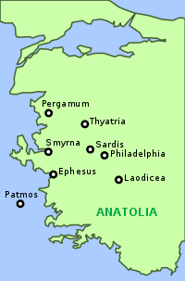
The 7 Letters to the 7 Churches in Asia Minor: Revelation 2 & 3

Letter 5 – The City of Sardis. In John’s day a traveler walking east from Ephesus reached Sardis in 3 days. Coming southward from Thyatira, he could cover the distance in 13 hours. The city had been the ancient capital of the kings of Lydia, of which the fabulously rich Croesus was the last, being subdued by Cyrus from Persia in 546 B.C.
Famous for its affluence, the city was situated above a fertile plain, irrigated by the gold-bearing Pactolus River and bounded on the south by Mt. Timolus. The broad ridged mountain and a cluster of sharp-sided promontories and highlands dominated the plain. On one of these easily defended ridges stood the stronghold of Sardis, 1,500 feet above the plain. It was a citadel and place of refuge, the residence of king and courtier.
The Greek historian Herodotus wrote that power and wealth breed arrogance and arrogance ends in ruin. In Sardis and the great King Croesus, the historian found a somber and striking illustration.
Sitting on the ridge high above the plain, the Sardinians thought that their fortress was secure, particularly along the rocky precipice that ran on one side. Smug and arrogant, the Sardinians set no guard there, thinking their city impregnable. So it was to this side that one of Cyrus’ Persian soldiers ascended the rock and found a way to sneak into the city, bringing about its fall. Perhaps that is the imagery reflected in the letter to the church when John is told to write: “Wake up! Strengthen what remains and is about to die. If you do not wake up, I will come like a thief, and you will not know at what time.”
Some 200 years later, Alexander the Great destroyed the Persian Empire and Sardis passed from hand to hand under the successive regimes. It was devastated by Antiochus the Great in 215 B.C., rebuilt, damaged greatly by earthquakes under the Roman Emperor Tiberias, and was at last completely destroyed in the 14th Century A.D. by Tartar hordes from the north.
With each new conquering nation, the Sardinians spoke long and eloquently about their past glory. However, Sardis, as the letter put it concerning the congregation, “had a name, but was dead.” Of all its world-renowned wealth and magnificence, there remains today only a few miserable huts of sheepherders in a paltry village nearby. A later historian wrote, “It was a city whose history conspicuously and pre-eminently blazoned forth the uncertainty of human fortunes, the weakness of human strength, and the shortness of the step which separates over-confident might from sudden and irreparable disaster. It was a city whose name was almost synonymous with pretensions unjustified, promise unfulfilled, appearance without reality, and confidence which heralded ruin.”

The Church in Sardis In the sacred writings of the Christian Church, Sardis has a place only in this chapter of Revelation. Some Christian inscriptions have been found in excavations, but no reliable information is known of the origin or end of the Christian community there.
All of the imagery in the apocalyptic letter vividly portrays the history of the place: “the reputation,” “the works undone,” “the thief in the night,” “the sudden surprise” at Jesus’ coming. It seems that the Christian community was infected by the complacency of the secular side of the city. They needed a “wake-up” call “to repent, to hold fast, and to keep watch.”
Did Jesus’ appeal to Sardis have any effect? It may have. Some 50 years later its bishop, Melito, published an apologetic (defense) treatise on the Christian religion from which the early church historian, Eusebius, has included creditable excerpts in his Church History. It appears that at least some “awoke,” “repented,” and “acknowledged Jesus’ name.” As they did, their “names were not blotted from the Book of Life.” Even now the faithful “are dressed in white” and “walk with Him” before “the Father and His angels” above.
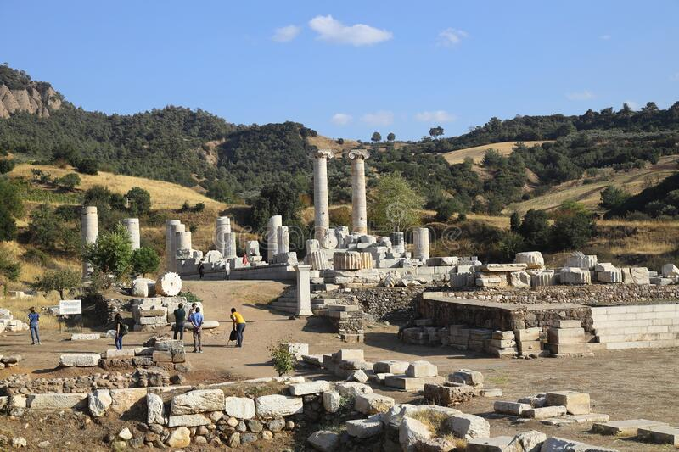
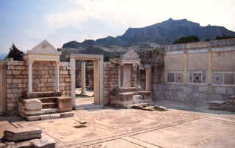

(adapted from the Zondervan Pictorial Encyclopedia and Sermon Study on Rev.3:1-6 by W.H.T.Dau)

