The Use of the Keys

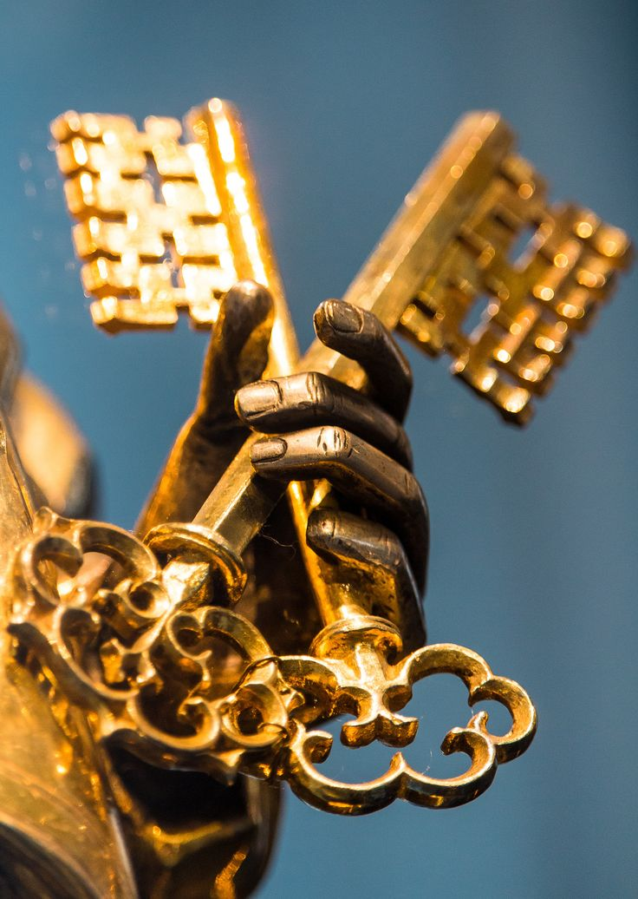
Keys can open doors and lock them. Those who possess keys possess a great deal of responsibility. They need to know when a door should be unlocked and when it should be shut tight.

God gives believers in Jesus the keys to open and close the door of heaven. Jesus said: “I will give you the keys of the Kingdom of Heaven; whatever you bind on earth will have been bound in heaven, and whatever you loose on earth will have been loosed in heaven.”
(Matt.16:19)

It might not seem right that God should give these keys to people. How can human beings ever handle this responsibility? Thankfully, God tells us in His Word exactly how to use the keys to the Kingdom of Heaven.

The power and right to forgive sins is the loosing key. It opens the door to heaven, declaring the person free from the guilt and punishment of sin. The power and right to refuse to forgive sins is the binding key. It locks the door of heaven, binding the person to the guilt and condemnation of his or her sin. Jesus said: Whenever you forgive people’s sins, they are forgiven. Whenever you do not forgive them, they are not forgiven. (John 20:23)

Some people don’t believe that their sins are serious or even that they have sinned. Others are driven to despair when they think of their sins. Jesus has given the keys to the Church in order to address the spiritual needs of both kinds of people. Martin Luther commented on this: “God gave the key which binds so that we might not remain too confident in our sins, arrogant, barbarous, and without God; and the key which looses so that we should not despair in our sins.”

Since Christ Himself has established this, the use of the keys by believers is as valid and certain in heaven also, as if Christ, our dear Lord, dealt with us Himself.
Luther’s Catechism, NPH 2017
The Ministry of the Keys
As the head of the family should teach them in the simplest way
to those in his household.

THE KEYS:
Pastor: First: What is the use of the keys?
The Use of the Keys is that special power and right which Christ gave to His church on earth: to forgive the sins of penitent sinners but refuse forgiveness to the impenitent as long as they do not repent.

All: Where is this written?
The holy evangelist John writes in chapter 20: “[Jesus] breathed on [His disciples] and said, ‘Receive the Holy Spirit. If you forgive anyone his sins, they are forgiven; if you do not forgive them, they are not forgiven.’”

THE PUBLIC USE OF THE KEYS:
Pastor: Second: How does a Christian congregation use the Keys?
A Christian congregation with its called servant of Christ uses the Keys in accordance with Christ’s command by forgiving those who repent of their sin and are willing to amend, and by excluding from the congregation those who are plainly impenitent that they may repent. I believe that when this is done, it is as valid and certain in heaven also, as if Christ, our dear Lord, dealt with us Himself.

All: Where is this written?
Jesus says in Matthew, chapter 16, “Whatever you bind on earth will have been bound in heaven, and whatever you loose on earth will have been loosed in heaven.”

