ASH WEDNESDAY – Peace Lutheran Church – February 18th, 2026

Hymn 140

Invocation

P: O Lord, open my lips.
C: And my mouth shall declare your praise.

P: Behold, we are going up to Jerusalem,
C: O Jerusalem, Jerusalem, you kill the prophets and stone those sent to you. (Matthew 23:37)

P: And everything that is written by the prophets about the Son of Man will be fulfilled.
C: Just as Moses lifted up the snake in the desert, so the Son of Man must be lifted up, that everyone who believes in him may have eternal life. (John 3:14,15)

P: He will be handed over to the Gentiles who will mock him and insult him,
C: All who see me mock me; they hurl insults, shaking their heads: "He trusted in the LORD; let the LORD rescue him. Let him deliver him, since he delights in him. (Psalm 22:7,8)

P: They will spit on him, flog him and kill him,
C: If anyone would come after me, he must deny himself and take up his cross and follow me. (Matthew 16:24)

P: And on the third day he will rise again.
C: Lord, by the victory of our Lord Jesus Christ, lead us onward — through death and resurrection — to the Promised Land of heaven. Amen.
Congregational Response – TLH 140 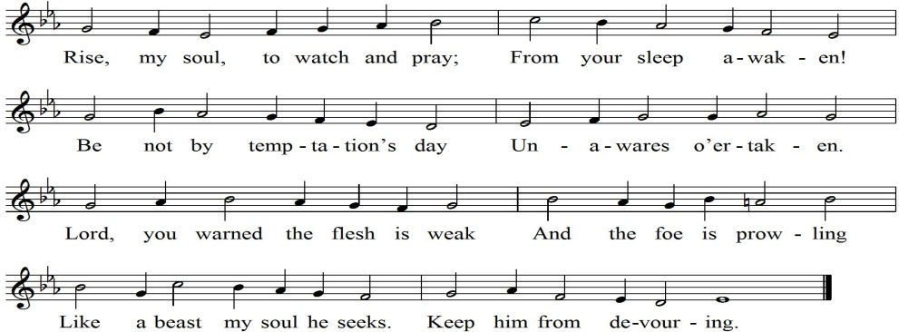

Lenten Responsary Psalm 130

P: Out of the depths I cry to you, O LORD;
C: O Lord, hear my voice.

P: Let your ears be attentive
C: to my cry for mercy.

P: If you, O LORD, kept a record of sins,
C: O Lord, who could stand?

P: But with you there is forgiveness;
C: therefore you are feared.

P: O Israel, put your hope in the LORD,
C: for with the LORD is unfailing love
and with him is full redemption.

READINGS: Isaiah 59:12-20 / Luke 22:14-20

P: The Word of the Lord
Congregational Response – TLH 151
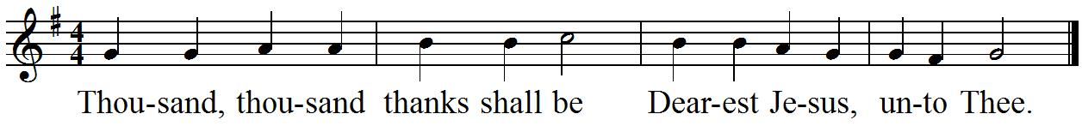

Hymn 371

Sermon…..Remember This? The Table – Luke 22:14-20

Response to the Sermon – TLH 172
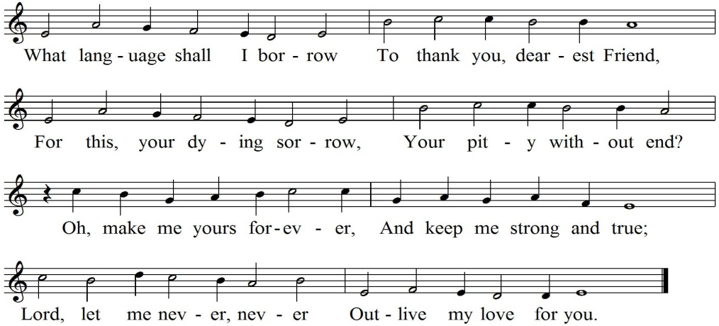

Offering

Prayer for Ash Wednesday

p.16 – Confession and Absolution

Words of Institution

Distribution and Hymn 307

Nunc Dimittis tune “Go to Dark Gethsemane” – TLH 159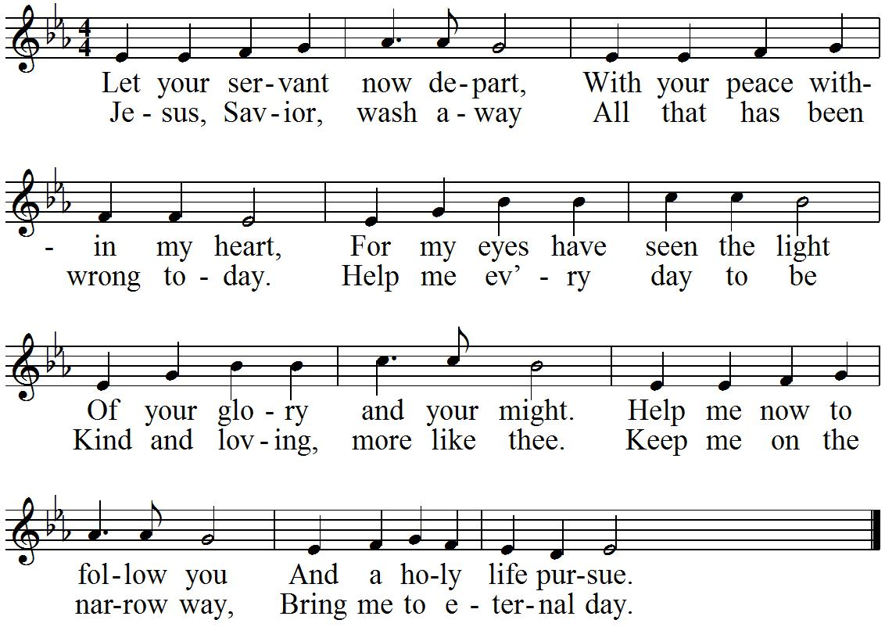

Lord's prayer

Benediction

P: The Lord bless you and keep you.
The Lord make his face shine on you and be gracious to you.
The Lord look on you with favor and give you peace.
C: Amen.

Hymn 558 (second tune) – verses are paired

ANNOUNCEMENTS
COMMUNION - This evening we have the privilege of receiving the Lord Jesus’ very body and blood together with the bread and wine, for the assurance of the forgiveness of our sins and the strengthening of our faith in him as our Savior. We ask that only those who are communicant members of a church in fellowship with the WELS or ELS come to the Lord’s altar. Please be sure to sign up on the sheet in the entryway of church.

PASTOR WILL USHER YOU OUT AT THE PEWS

